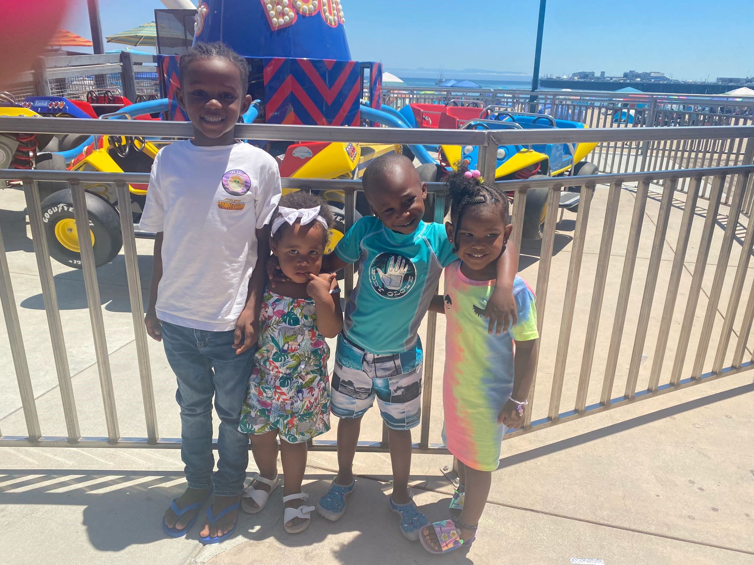
Our mission
Promoting community health, wealth and engagement through healthy food education, technology and online assistance, neighborhood drives, giveaways, and events.

Our Services:
- Community Drives & neighborhood giveaways
  - Sock Drives
  - Backpack Drives
  - Adopt-A-Family
  - Scholarship Programs
- Healthy food education & food assistance programs
- Technology and Online assistance
  - Online application help
  - Email set up & education
- Mentoring Services
  - Financial
  - Educational
  - Life & daily stress
“I have found that among its other benefits, giving liberates the soul of the giver.”
Maya Angelou

www.thevictorymovement.net

